from: Robert W Malone MD from "Who is Robert Malone" <rwmalonemd@substack.com>
reply-to: Robert W Malone MD from Who is Robert Malone <reply+1hhx8a&doii8&&46335d257ba4e453c9bd6bf69eed00be8393c820e8660e3d35cf26a94f40fd38@mg1.substack.com>
to: fchase@gmail.com
date: Dec 11, 2022, 7:40 PM
subject: Controlled Opposition, Black Propaganda
mailing list: rwmalonemd@substack.com Filter messages from this mailing list
mailed-by: mg1.substack.com
keywords: controlled-opposition (15 results),

Open in app or online

Controlled Opposition, Black Propaganda
  - Risk assessment, paranoia, strategy or reality?
ROBERT W MALONE MD, MS
DEC 12
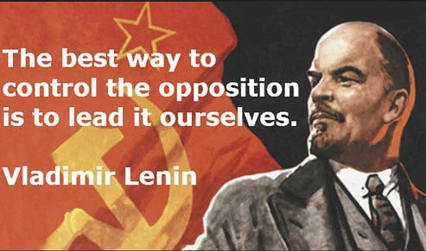
The best way to control the opposition is to lead it ourselves.
Vladimir Lenin
[The words and image of Lenin are instantly, almost wordlessly, apprenended. I find it much much slower going to absorb the more precise but wordy definition and discussion below! -FNC]
Controlled Opposition: a strategy in which an individual, organization, or movement is covertly controlled or influenced by a 3rd party and the controlled entity’s true purpose is something other than its publicly stated purpose. The controlled entity serves a role of mass deception, surveillance and/or political/social manipulation. In most cases the controlled party is portrayed as being in opposition to the interests of the controlling party.
• Preempt or neutralize true but negative information by having it be disclosed or championed in a skewed/stigmatized manner by a person or group. The truth can be peppered with disinformation or the truth of the message can be neutralized by association due to the extreme, radical, or unpalatable positions held by the controlled entity (person or group) who is disclosing the information or is “championing” a position. The stigmatized or adulterated truth in turn steers people away from truthful information which would normally cause criticism or a serious backlash against the controlling party. Stigmatized truth also greatly inhibits independent research into sensitive areas (usually involving criminal acts by the controlling entity) and serves to manipulate social dynamics in a manner in which it becomes taboo to publicly discuss sensitive (albeit critically important) subjects.
Operation Trust: [Example] The objective of the Bolsheviks was to create a controlled opposition to entrap the rements of the supporters of the Russian Monarchy.
Source: Urban Dictionary

Black propaganda is a form of propaganda intended to create the impression that it was created by those it is supposed to discredit. Black propaganda contrasts with gray propaganda, which does not identify its source, and white propaganda, which does not disguise its origins at all. It is typically used to vilify or embarrass the enemy through misrepresentation.
The major characteristic of black propaganda is that the audience are not aware that someone is influencing them, and do not feel that they are being pushed in a certain direction. Black propaganda purports to emanate from a source other than the true source. This type of propaganda is associated with covert psychological operations. Sometimes the source is concealed or credited to a false authority and spreads lies, fabrications, and deceptions. Black propaganda is the "big lie", including all types of creative deceit. Black propaganda relies on the willingness of the receiver to accept the credibility of the source. If the creators or senders of the black propaganda message do not adequately understand their intended audience, the message may be misunderstood, seem suspicious, or fail altogether.
Governments conduct black propaganda for a few reasons. By disguising their direct involvement, a government may be more likely to succeed in convincing an otherwise unbelieving target audience. There are also diplomatic reasons behind the use of black propaganda. Black propaganda is necessary to obfuscate a government's involvement in activities that may be detrimental to its foreign policies.
Source: Wikipedia

Related to the above are infiltrate and disrupt campaigns. Examples of how this strategy is deployed can be found in the following articles:
Infiltration to Disrupt, Divide and Misdirect Is Widespread in Occupy
Infiltration of Political Movements Is the Norm in America
According to “Surveillance and Governance: Crime Control and Beyond,” FBI field operatives were directed to:
1. Create a negative public image for target groups by surveilling activists and then releasing negative personal information to the public.
2. Break down internal organization by creating conflicts by having agents exacerbate racial tensions, or send anonymous letters to try to create conflicts.
3. Create dissension between groups by spreading rumors that some groups were stealing money.
4. Restrict access to resources by pressuring nonprofit organizations to cut off funding or material support.
5. Restrict the ability to organize protests through agents’ promotion of violence against police.
6. Restrict the ability of individuals to participate in group activities through character assassination, false arrests and surveillance.
The COINTELPRO documents disclose numerous cases of FBI attempts to stop the mass protest against the Vietnam War. Many techniques were used. The documents state: “These included promoting splits among antiwar forces, encouraging red-baiting of socialists, and pushing violent confrontations as an alternative to massive, peaceful demonstrations.”
For further examinations of current Fifth Generation Warfare (5GW) battlefield tactics, I recommend this set of essays by Matthew Crawford, who spends a lot of time investigating and thinking about these matters. I do not always agree with Matthew, but I always listen to what he has to say. He is damn smart.
Keep in mind that in 5GW, you and your mind are the battlefield. Controlling the narrative and by extension your very thoughts and emotions are the objective.
The Themis Report: A Documented War/Espionage Tale? Chaos Agents, Part 1
How the Magic Trick Works: Cutting Off Effective Resistance. Chaos Agents, Part 2: Libet Experiments and Readiness Potential
Stew Peters' Chaos: Credibility that Died Suddenly, Part 1. Chaos Agents, Part 3
Stew Peters' Chaos: Credibility that Died Suddenly, Part 2. Chaos Agents, Part 4
Stew Peters' Chaos: Credibility that Died Suddenly, Part 3. Chaos Agents, Part 5
Also of relevance is this Children’s Health Defense article:
New Report Details Efforts to Infiltrate, Disrupt Health Freedom Movement
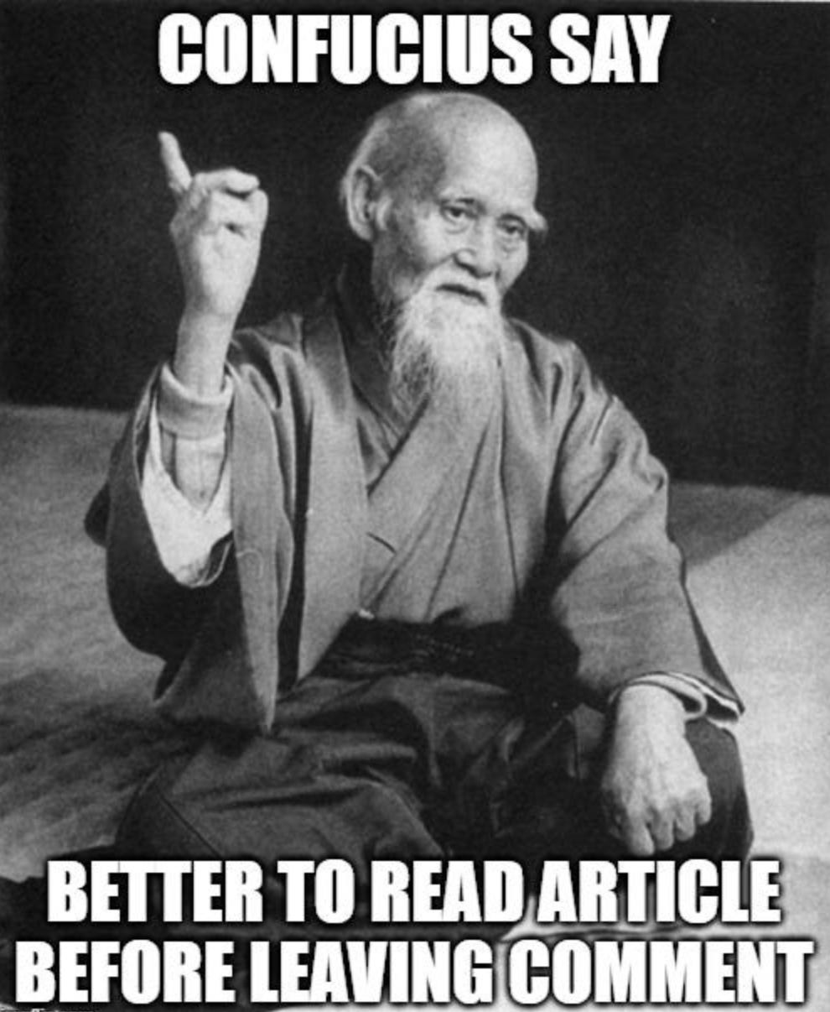

In a way, the rise of efforts to discredit others through accusations of “Controlled Opposition” or “he/she is a Deep State operative” may be an implicit acknowledgment that the “White Propaganda” efforts to compel and coerce the public to comply with the WEF/WHO/US Cybersecurity and infrastructure security agency (CISA) COVIDcrisis agenda have largely failed. A global resistance movement has developed, the lies and misdirection of corporate and social media (and big Tech) have been revealed, and much of the populace has become increasingly sophisticated in its ability to spot and reject “White Propaganda”. It has become necessary for those seeking to “control the narrative” and “shape” the fourth industrial revolution/Great Reset to shift tactics. And so it is not surprising that we now see an increasing emphasis on the well developed “old school” tactics of infiltration and disruption.
The list of those so accused of being “controlled opposition” or a “Deep State operative” within the opposition to government, WEF, WHO, and others promoting the COVIDcrisis narrative and associated dysfunctional public health polices has grown quite long recently. These include the following, some of whom may actually be “controlled opposition”, and others who clearly are not:
Steve Bannon
Del Bigtree
myself [Robert W. Malone MD] (no, it is not all about me!)
Robert Kennedy Jr.
Reiner Fuellmich
Stew Peters
Alex Berenson
Patricia Rodriguez (nee Carolina Bonita, nee Carolina Rodriguez), who manages (managed?) the social media accounts of a widely admired “leader” in this effort.
and many, many others.
Got someone that you want to “take down” because you do not like their politics, they are not sufficiently radicalized to your standards, you think they are getting too much attention, or they offended you because they would not come on your podcast? For example, see the “Nobel Prize Nominee” Ben Marble quotes in this article. I mean, really. What does Ben Marble know about my relationship with God and religion? Rather presumptive, at a minimum. The word “Hubris” comes to mind for some reason. J’accuse vous of controlled opposition. “Off with their heads” (metaphorically).
“Trojan Horse” is another favorite irresponsible but effective accusation.
This type of slander and defamation is an all-purpose “gift that keeps on giving”. As I often point out, the accusation cannot be refuted. Anything said is turned into a validation of the accusation. “Have you stopped beating your wife” is another example of this type of logical fallacy. This is akin to the accusation of witchcraft. Any attempt to refute the accusation only serves to confirm in the mind of the accusers that the accused is actually a witch.
https://www.youtube.com/watch?v=fr8DIg3oHFI Burn the Witch (Monty Python).

SO, lets take another look at that COINTELPRO checklist-
1. Create a negative public image for target groups by surveilling activists and then releasing negative personal information to the public.
Yup. Seen that. In at least two major resistance/medical freedom organizations
2. Break down internal organization by creating conflicts by having agents exacerbate racial tensions, or send anonymous letters to try to create conflicts.
Yup. Directly and personally experienced that one from Carolina Galvin/Bonita/Patricia Rodriguez.
3. Create dissension between groups by spreading rumors that some groups were stealing money.
Yup. Seen that also in at least two major resistance/medical freedom organizations.
4. Restrict access to resources by pressuring nonprofit organizations to cut off funding or material support.
Yup. Experiencing that directly myself over the last few weeks.
5. Restrict the ability to organize protests through agents’ promotion of violence against police.
Yup. Again, Read the Themis Report and the associated Bonita Report.
6. Restrict the ability of individuals to participate in group activities through character assassination, false arrests and surveillance.
Uh, yeah. Seen a bit of that also. From both corporate media as well as from the conspiracy-oriented fringe.
Here is the list of tactics being deployed as highlighted by the Children’s Health Defense article cited above:
- Infiltrate, mimic and ultimately hijack existing groups by piggybacking on brand recognition.
- Target group owners, earn trust and then install bots that enable the takeover of the group to assert new identities and goals.
- Control content that can be shared within groups and distort group missions.
- Steer groups toward aggressive or unproductive behavior and confuse members with regard to peaceful protest locations and assertion of values.
- Harvest private data and information related to health freedom strategies.

I had a long discussion over dinner with a colleague (who made the “controlled opposition” list above) after the first (planning) day for the recent Ron Johnson hearing. Among other things, we discussed this accusation. As usual, he flipped the script with some fascinating observations:
- If someone is accusing you of being controlled opposition, they are either just being intellectually lazy (see the Monty Python “Burn the Witch” clip above), or they are actually thinking. If they are really thinking for themselves, rather than just regurgitating someone else’s accusation, then that is a good thing!
- When the claim is made, ask the person what they imagine the end game, the objective of the accused is. In my case, do my accusers imagine that I am suddenly going to flip and try to entice those that follow me to take the mRNA jabs? Again, watch Monty Python’s take on witch burning. Like all good comedy, it captures deeper truths.
- In his opinion, at this phase, when we are seeing such clear evidence of infiltration, disruption, chaos, and the COINTELPRO strategies being deployed, each of us needs to ask ourselves - in every new interaction (physical or virtual) involving resistors to the COVIDcrisis narrative- is this person controlled opposition?
His dinner conversation left me with a lot to ponder.
If we are to take this approach of always being wary of infiltration, disruption, and true controlled opposition, then it will become exceedingly difficult to establish and maintain community bonds. In order to gain trust and friendship you usually have to first extend it. If we find ourselves constantly questioning who is to be trusted, then our opponents will have succeeded, for our growing community will be destroyed. As is already happening. Somehow a middle ground must be found. Wary trust? Keep in mind that the biblical sayings regarding the meek inheriting the earth were based on a meaning of meek which is closer to “humble strength”.
Personally, having experienced decades of academic predation and wicked politics (“Academic politics are so vicious because the stakes are so low”) which at one point yielded a nervous breakdown and diagnosis of PTSD, my general rule of thumb has become the three strikes rule. If someone damages me or my reputation once, it could be an oversight. Twice and my radar goes up. Three times and they are out. I apply the “No Asshole Rule”, partition the offender out of my life to the extend possible, and move on. You cannot maintain integrity when forced to deal with those who have lost theirs.
By the way, accusing someone of being “Controlled Opposition”, “Deep State”, or of spreading mis- dis- or mal- information is to accuse them of fraud. Of misrepresenting facts or intent. Fraud. Fraud is a serious accusation. Accusing someone of Fraud is defamation if you cannot prove your case. And doing so maliciously will overcome the infamous “Sullivan vs New York Times” case which the corporate media lawyers like to cite to justify defamatory statements leveled against those determined to be “public figures”. So, anyone making such statements is either ignorant, highly irresponsible, inviting a lawsuit, or they better be able to back up their claims with clearly demonstrable facts.
I suggest that the first step when evaluating accusations of “Controlled Opposition”, “Deep State”, or of spreading mis- dis- or mal- information should be to turn your attention on the person throwing the bomb. Is it a truth bomb? Are such accusations well reasoned? Are the person(s) making the accusation prone to wild conspiracy theories and paranoid thinking? Are they deploying the “FearPorn” or “Stoking Rage” business models to gain clicks, ranking, eyeballs and advertising revenue? Do they have a conflict of interest, an axe to grind?
In some cases, the answer is clear. In most, not so much. And the most skilled infiltrator/disrupters are experts in convincing others that they are on the square, one of “us” (whomever “us” happens to be at the time). They are skilled at gaining the trust of one member of a group, and then leveraging that to gain access to others.
After you evaluate the accuser, their motives and history, I suggest that THEN you turn to the accused. What is their behavior? What is their track record? Words matter, but actions speak louder than words. Then ask yourself, “what would it benefit this person to compromise their integrity and serve as “controlled opposition”? What does it profit a man, to gain the world, but lose his soul? And keep in mind that conflict of interest is a powerful thing.
Think for yourself. That is the point. If you wish to maintain personal sovereignty, you must walk your own path. Do not take what I say, or what anyone else tells you, as the gospel truth. Always question and think.
In closing, one of the most powerful forces which cause someone to lose integrity and serve another master is money. Mammon, if you will.
Jill and I are almost exclusively depending on those substack subscribers who elect to join as paid subscribers. We publish these on a daily basis free for all to read, and only restrict the comments section to those who volunteer to pay a modest fee. We made that choice over a year ago when we launched this endeavor, and it has served us well. This is not a plea for money, but rather an explanation. We treat all of our subscribers, but particularly those who pay, as our clients. Jill and I have run a consulting business for decades (until we destroyed it by speaking out about the fraud, abuse, harms and breaches of ethics). But heres the thing. We have lots of subscribers. Almost 250,000 total, of which only a small fraction pay a monthly fee. The result is that we are not beholden to any one subscriber. If someone gets aggressive or rude, they get “unsubscribed” (see above RE “The No Asshole Rule”).
Just like when a politician choses to rely on many small donations rather than a big check from a small number of interests, this frees us up to speak and write truth as we see it. In a very real way, our subscribers have set us free.
And for that, we thank you. And we will continue to strive to act with integrity, to respect human dignity, and to strive to build community.
All we ask of you is that you think for yourself. And to do your personal best to not jump to conclusions, defame or attack others without due cause. If we can “influence” and “shape” your thoughts and behaviors towards those ends, it will be a “win” for all of us.

Subscribed

